Warehouse Naming Guidelines
As a result of the meeting we had on the 23rd July 2014 to discuss the labelling of locations within Gough Group warehouses we agreed the following.
- Aisle. This is the aisle identifier of a row of shelves in the warehouse. We will use two letters. The first letter will be either ‘R’ to represent Racking or ‘S’ to represent a small binning row of shelves. (R = Racking, S = Small binning) The second letter represents the location of the rack or small binning in the warehouse.
- Bay. We are using two numbers. This is the Bay identifier within a rack.
- Shelf. We are using one letter. This is the Shelf identifier which is the shelf position from the floor. ‘A’ is the floor or the lowest shelf, B the next shelf from the floor and so on dependent on the number of shelves in the bay.
- Position. This is a 2 digit number. Position is the place on the shelf identified left to right when you look at the rack
- Bin. This is a letter and represents position depth on the shelf
An example of the format of this location identifier is RG01B03.
RG = Rack G
01 = 1st bay from one end
B = 2nd shelf up from the floor.
03 = Position 3 from the left on the shelf
In most instances it will be only necessary to go to the level of Shelf for the purposes of identifying locations. However where there are areas of high density storage there is the option to use both Position and Bin to be able to assign a unique location identifier.
The location code in NAXT has a maximum number of 10 characters.

Racking

Aisle |  | Bay |  | Shelf | Position
R | A | 0 | 2 | B | 0 | 1

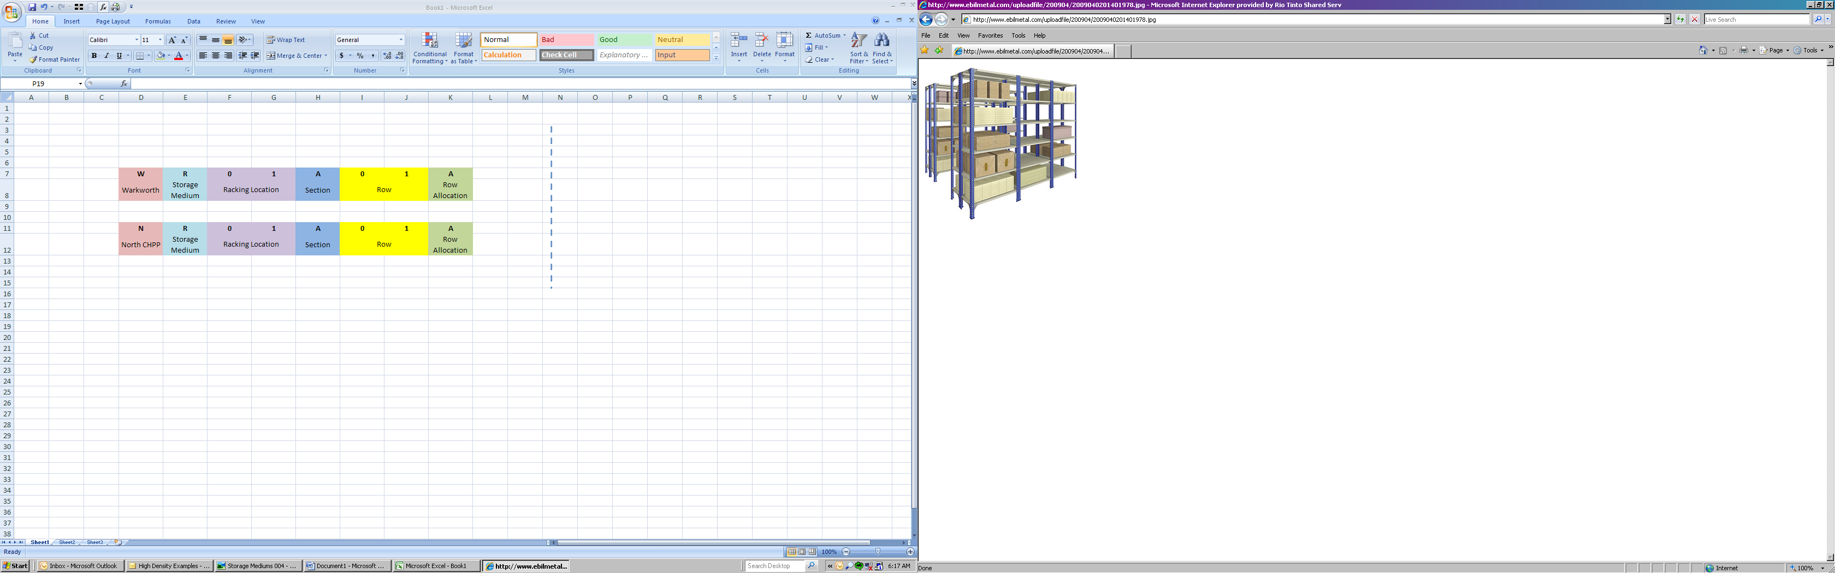
Rack
A
B
C
D
| Bay 01 | Bay 02 | Bay 03 |
Examples
RD01E02
RD03C01
RD01B02
| 01 02 03 04 05 | 01 | 01 02 |
Shelf E
Shelf D

Shelf C
Shelf B
Shelf A
Position
High Density

Aisle |  | Bay |  | Shelf | Position |  | Bin
S | A | 0 | 2 | C | 0 | 3 | B

Bin
C
B
A
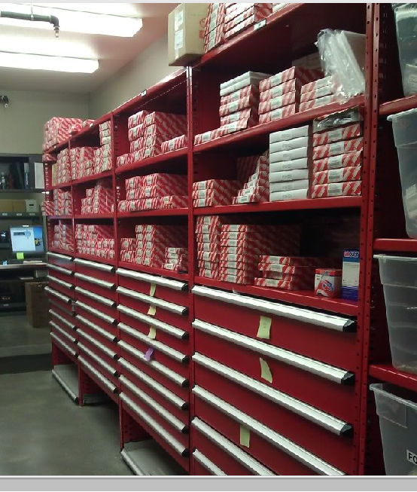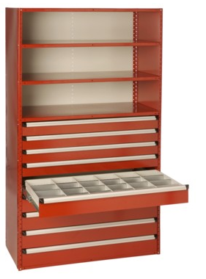
Bay
01 02
03 04
Shelf
C
B
A
01 02 03 04 05 06
Position
Examples
RA03I02 RA04H03

